# Practice exercises #2-1

1. Write a Python program that inputs:
   1. the radius of a circle
   2. the units of measurement (mm, cm, m or km)

and outputs the circumference and the area of the circle in the correct units, rounded to to 1 decimal place.  
  
Example output:

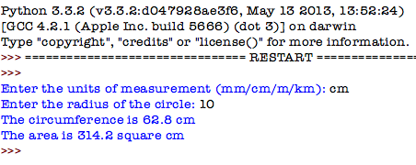

1. Write a Python program that asks the user his or her age, then outputs whether he or she is old enough to drive, vote, and drink alcohol.  
     
   Example output  
     
   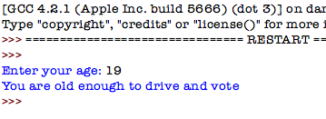
2. Write a Python program that tells a Mad Libs story. Ask the user to enter:
   1. the name of a character
   2. Whether the character is male or female (so the program can use “he” or “she” during the story)
   3. 2-3 different nouns

Then print out a silly story that has the user’s character and inserts the user’s nouns at funny places.   
  
Example

